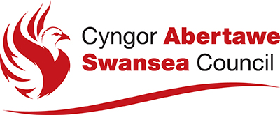
Practitioner Request for Information, Advice and Assistance
From the Early Help Hubs or the Single Point of Contact

Guidance for completing the Practitioner Request for IIAA
(Integrated Information Advice and Assistance Team)

- If a child/young person who you are working tells you that they are worried about something; you should talk to them about their worry. Ask them what they would like to happen that would make them feel better – ‘What Matters’. Be clear with them that dependant on the nature of the worry; you will probably need to speak to other people about it, including in the first instance their parents. For wellbeing issues identified by involved professionals, contact should be made with the parent or carer to share the worries and clarify what matters to them.

- Wellbeing needs that can be met by providing information to the family, would entail you giving them information about community resources that can be accessed directly by them. This can include sharing details of websites, helplines or providing information about advice leaflets.

- Wellbeing needs that can be met by providing advice to the family would include things such as basic parenting/behaviour management.

- Wellbeing needs that would require an intervention to help the family to achieve would be considered as assistance. This could include you either providing the intervention yourself, or assisting the family to access support from another service. This would be considered the beginning of a proportionate wellbeing assessment; and should include clear and achievable outcomes with timescales, that you should agree with the family and include who is going to do what. To access support for the family from the Early Help Hubs, please forward the completed form to earlyhelphubs@swansea.gov.uk. You can also call the EHH on 01792 635400 and ask to speak to one of the area team leaders or senior lead workers for advice and guidance on how to complete the form.

- If during a ‘What Matters’ conversation; you identify that the family have needs that you think may be eligible for care and support from statutory child and family services, then you should talk to the family about this and seek their authorisation to share the information with IIAA. This information should be recorded on the EHH/SPOC MARF (Multi-Agency Referral Form), which can be forwarded to the IIAA Team at: access.information@swansea.gov.uk.

- If during a ‘What Matters’ conversation; you receive information from a third party or if you observe something that leads you to have reasonable cause to suspect that a child is suffering or is likely to suffer significant harm, you should first discuss this with the named Safeguarding Lead in your organisation. If they are not available, or they agree that you need to speak to a qualified Social Worker you should then contact IIAA. You should still talk to the family about this; and seek their authorisation to share the information with IIAA and there should be a presumption of openness, unless to do so would compromise the child’s safety. Reasons for withholding information from a family should be clear and recorded and explain why in these circumstances. Safeguarding and promoting the welfare of the child must always be the overriding consideration. You should contact IIAA to discuss your worries by calling 01792 635700. This information should also be recorded on the EHH/SPOC MARF which can be forwarded to the IIAA Team at: access.information@swansea.gov.uk as soon as possible.

- When a professional contacts IIAA to talk about a family the first person they speak to will be a qualified Social Worker, who will establish if the family have agreed for them to share information before taking any identifiable details. If the family have agreed then the Social Worker will clarify if the professional has had a ‘What Matters’ discussion with the family and recorded it as the start of a proportionate assessment. If they have then the Social Worker may request a copy is sent to them. If not then the caller will be advised to do this in order to identify whether the needs can be met by preventative services, or by the family themselves with or without the assistance of others. If the family already have an allocated lead worker from the EHH; in the absence of any child protection concerns the caller will be directed to the lead worker, for them to consider whether they can work with the family to achieve their personal outcomes or whether a step up to statutory services is required. If the family are considered to have eligible care and support needs then the information can be shared verbally and then followed up in writing.

Whether a child is having a proportionate assessment by universal services, EHH, IIAA or a statutory assessment of care and support needs; professionals should always consider the five elements from the SSWB (Wales) Act (2014). These are in line with the assessment tool in the Signs of Wellbeing and Signs of Safety Framework.

- The personal circumstances of the child and family.
- What are the personal outcomes for the child and family? (wellbeing or safety goals).
- What at the risks to the child if nothing changes? (worry or danger statement)
- What are the barriers for the child and family in achieving their wellbeing goals? (complicating factors)
- What is already working well for the family, what strengths and capabilities do they have? (existing strengths and safety)

Do you have any safeguarding concerns for children?

If yes, the concerns need to be shared immediately by telephone with:
- Relevant partner agency
- Police (999/101)
- Social Services Single Point of Contact 01792 635700

IT IS EVERY PERSONS RESPONSIBILITY TO REPORT A CONCERN

For 3rd sector/Universal Services, please visit https://www.dewis.wales

Do you consider this referral to be for?
- Early Help Hubs ☐
- Safeguarding Concerns ☐

Has authorisation been obtained from the family? Yes / No Verbal / Written

Referrer Details
Date of request:
Name of practitioner making the request:
Agency details: (including contact address)

Telephone number:
Email address:
Tick if request relates to:  Young Carer | Disabled child | Carer

“If any person has knowledge, concerns or suspicions that a child is suffering, has suffered or is likely to be at risk of harm, it is their responsibility to ensure that the concerns are referred to social services or the police who have statutory duties and powers to make enquiries and intervene when necessary” All Wales Child Protection Procedures, 2008.

Details of the child/young person
Name: | DOB: (or EDD) | School / College: | Ethnicity/Language:
Address:
(including postcode)

Telephone Number:
Disability/Carer: | Please give details:
Communication/ Advocacy needs:
Preferred language of the family?

Family Members
Relation: | Name: | DOB: | Ethnicity/Language: | Address: | Telephone:

What other assessments and services have been undertaken by other agencies? Past and present
Agency: | Contact Name: | Telephone: | Previous/Current: | Supporting: (name of family member)

Reason for contacting Early Help Services/SPOC: What are the personal circumstances of the
child/ren and their family that have led you to contact the department?
Give details of what has led up to this and also state child/ren and parent/carers view.
What other support has been offered and did the family engage well with this?
Who in the family is most involved with the child?
Who sees the child the most?

Value Step 1 – Understand the issue

What Matters to the family? – Information for this section to be gathered from the child and their parent/carer
What is working well? Strengths and capabilities
What is going well for the child/ren and their parent/carers?
Who helps to keep the children cared for and safe?
Who does the child trust the most/who do they have the best relationship with?

What are you worried about? Risks and issues
What harm has happened to the child/ren?
Who has suffered any harm?
Are there children who are at risk of suffering from harm?

Complicating factors/Barriers to achieving change
What are your main worries for the children and their parent/carers if nothing improves?
What do the family struggle with the most?

Value Step 1 – Understand the issue

What Matters to professionals involved with the family? - Information to be included in this section from an involved professional/service perspective
What is working well? Strengths and capabilities
What is going well for the child/ren and their parent/carers?
Who helps to keep the children cared for and safe?
Who does the child trust the most/who do they have the best relationship with?

What are you worried about? Risks and issues
What harm has happened to the child/ren?
Who has suffered any harm?
Are there children who are at risk of suffering from harm?

Complicating factors/Barriers to achieving change
What are your main worries for the children and their parent/carers if nothing improves?
What do the family struggle with the most?

Value Step 1 – Understand the issue

Personal Outcomes that the parents/carers want to achieve for the child the personal outcomes should be agreed by the child, their parent/carer and the professional completing the form.
Social and Economic Wellbeing
Physical and mental health and emotional well-being
Protection from abuse or neglect
Education, training and recreation
Domestic, family and social relationships
Suitability of living accommodation
Securing rights and entitlements
Contribution made to society

Tick the boxes and provide details under the appropriate headings using the guidance included in the wellbeing wheel below.

Value Step 1 – Understand the issue
Value Step 2 – Explore Options and solutions

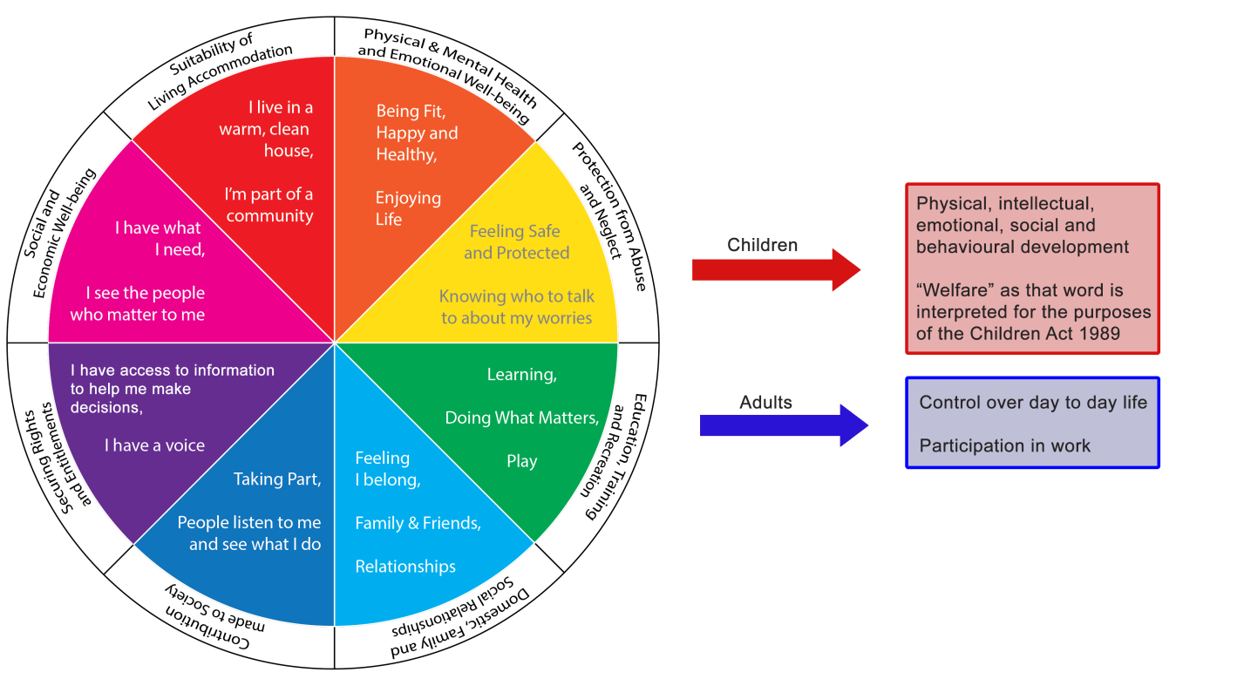

Next Steps - To include any actions agreed by the child, family or involved professionals.

What needs to happen? | Who will do it? | When will it be done?

